Prof. Dr. P.B. Sivaraman
Consultant Urologist,
Chairman, CURI Hospital

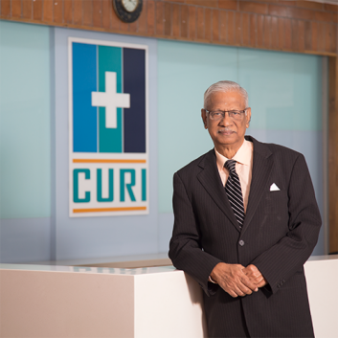
Dr. P.B Sivaraman is currently, the Chairman of Chennai Urology and Robotics Institute Hospital (CURI Hospital) - which is a dedicated Urology and Robotic Surgery hospital aiming to make advanced urological care affordable, to serve the community

He is a distinguished and well-known Urologist and as the professor and Head of the Department at Madras Medical College, he has left behind a legacy of urologists trained by him who are leaders in their field of work across the country.
Dr.P.B.Sivaraman completed his Basic and higher medical education (MBBS and MS General Surgery ) and his specialization in M Ch, Surgical Urology at Madras Medical College, Chennai. He further completed his Fellowship (FRCS) at the Royal College of Surgeons at Edinburgh.
He has worked for 5 years in higher training at various Urology Department centers in the UK. He was also the consultant urologist, at King Khalid Hospital, in Saudi Arabia. He has had training in Cadaver Kidney Transplantation at the Medical Centre and Transplant Laboratory and Polish Academy of Sciences, Warsaw, Poland.
Dr. P.B. Sivaraman is one of the most experienced and respected Senior Urologists in the country. He is one of the first surgeons to perform cadaver kidney transplantation in a Govt Institution in India. He is credited with nearly 2000 successful kidney transplants.

He wore several awards under his hat.
He is credited with nearly 2000 successful kidney transplants, and an appreciation of his yeoman service to poor patients, he has been awarded the Life Time Achievement Award by Rotary by the Rotary Club of India (Chennai).
He has been honored with the Doctor of Science (D.Sc) by MGR Medical University, Chennai.
In recognizing his contributions as a Urology teacher his students and assistant professors have instituted an endowment oration in his honor in the urological society of India.
In Appreciation of his services to Urology and Teaching skills, The Urology Society of India (Tamilnadu and Pondicherry) Awarded him "UROLOGY GOLD MEDAL".
He has served as the President of premier Professional Bodies in Urology in India such as the Tamil Nadu Pondicherry Urological Society and Madras Urological Society.
He is also the Founder Member of Cancer of Prostate Endeavors(COPE), an organization involved in research and creating awareness of Prostate Cancer.
He is a life member of the Urological Society of India. He also has full registration with the General Medical Council of the UK.
He is also a member of the Indian Society of Organ Transplantation, a Scholar Indian National Science Academy, and a member of the Uro sphere

